TITLE OF THE PAPER- MUST BE CLEAR, BRIEF, AND INFORMATIVE
First Author^{*a}, Second Author^{b}, Third Authorª
ªSchool of Creative Industry Management & Performing Arts, Universiti Utara Malaysia, Malaysia
^{b}Communication Department, Universitas Islam Indonesia, Indonesia

*Corresponding author email: author@institution.com

ABSTRACT:
The abstract should summarize the contents of the paper indicating problem, methodology, results, and implication of the study. It is an original work, not an excerpted passage. An abstract must be fully self-contained and make sense by itself, without further reference to outside sources or to the actual paper. It highlights key content areas, your research purpose, the relevance or importance of your work, and the main outcomes. It must contain at the most of 250 words with 10-point font size, single spaced, and justified alignment. The abstract should be in one concise paragraph only. The function of the abstract is to outline briefly all parts of the paper.
Keywords: my keyword1, my keyword2, my keyword 3
Introduction
Your paper will start with the introduction explaining the objectives, theory, methodology, and contribution. Please strictly follow the author's guidelines, otherwise your paper might be technically unsuitable and would be returned for a revision.
Each new paragraph shall be delineated by indenting the first line at 0.51 cm, with 6pt line spacing before. In-text citation must use APA (American Psychological Association), showing the author's last name and the year of publication, and without footnote (Lastname, 2024).
Any text to the headers and footers, as well as page numbers must not be individually set because text will be added electronically. For the best viewing, the paper must be set in a camera-ready format.
Shall you need to attach tables, figures, or other illustrative complements, make sure that the instructions are followed closely.
All tables and figures must appear inside the designated margins or they may span the two columns. Tables and figures in two columns must be positioned at the top or bottom of the page within the given margins. It is advisable for the tables to use of text boxes in this case.
The section heading should be capitalized for each of the word and written in bold in 11-point font size. Sub-section heading can be added should not be capitalized all words.
Related works
In recent years, a lot of studies on terrain visualization based on the game engine have been conducted. Ruzinoor, Mohammed, Nasir, Mohd, and Hafiz (2014) reviewed terrain engines of the four-game engine which is a torque game engine, unreal game engine, unity 3D and CryEngine. Shiratuddin and Fletcher (2006) developed a 3D environment for Hattiesburg Innovation and Commercialization Park (ICP) for the University of Southern Mississippi using modified version of torque game engine. In another research by Shiratuddin and Thabet (2011), DBMS was utilized as a plugin for torque game engine database that would hold most information as 3D model to create a design review system. Mateevitsi, Sfakianos, Lepouras, and Vassilakis (2008) studied about representing museum artifacts information that also utilizes DBMS for torque game engine. In growing palm oil tree, Bahrin et al. (2014) used controlled fertilizer allocation in his studies on palm oil tree cultivation. Palm oil tree requires a flat surface for better irrigation in which the attraction of water into the land is sufficient and there is no visible water puddle around the tree; this also allows faster harvesting of palm oil fruit (Food and Agriculture Organization, 2015). Diseases also occur on palm oil tree, fungal and root diseases require a careful inspection to determine the infected tree (Lelong et al., 2010). Asraf, Nooritawati, and Rizam (2012) studied on identifying palm oil leaves nutrient-disease using computer vision to visualize chemical such as nitrogen.
METHODOLOGY
The development of web-based 3D terrain visualization using unity 3D game engine can be divided into several stages which included data preparation, image preparation, construction of 3D terrains, generated terrain using unity 3D, overlaid terrain, database construction, web-based development and deployment. All these stages were related to each other where one needs to be completed before proceeding to next stage. Figure 1 shows the sample of colour figure.
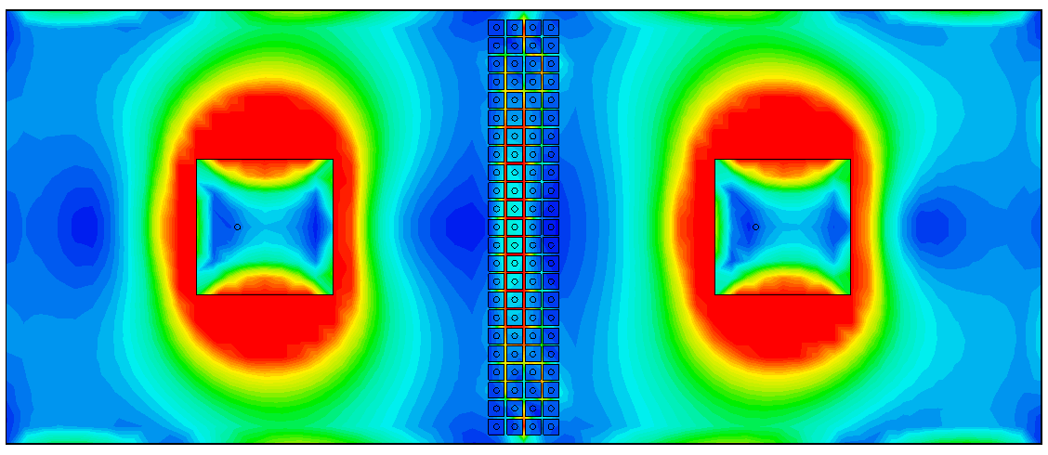
Figure 1. A figure caption is always placed below the illustration

Data preparation (This sample of Sub Heading)
Data preparation for this system development is performed by using the ArcGIS software. The process started by adding the selected terrain data into the project in ArcGIS. Every selected area has a different project file. The data is then converted into Triangular Irregular Network (TIN) layer based on the height of the selected contour area. The DEM data format that can only be accepted by the game engine was HDR (header) with FLT (float) data format. The projection used for this data was the Rectified Skew Orthomorphic (RSO) Peninsular Malaysia.
Image preparation
In this stage, the image of the data should be in raster format. The image data could be the land use map, aerial photograph data, and satellite image. For this project, the satellite image data were used. The projection used for this data is similar to the terrain data (DEM format) which is in RSO format. In order to be fitted with the terrain data, the land use map and satellite image data need to be clipped so that it covers the same area as the terrain data. The PCI Geomatica software is used to clip the image data. The four coordinates for clipping the image data is similar as coordinates in terrain data. The process started with opening all of the image data. Then the process continued with inserting four coordinates to be clipped. Determination of the destination of output files and formatting of files also need to be done. Finally, the data is clipped based on the four coordinates set before and was saved in TIFF format.
Web-based development
After the construction of the terrain was completed, the web-based development of terrain was started. The Macromedia Dreamweaver was used to develop the complete website for online 3D Terrain Visualization with oil palm tree data using game engine. The development process began by drafting a design for the website based on the developer creativity. Then web-based format data was arranged according to the design. The display of these two links for the prototype was in the main frame area. In order to view this prototype, the user would need to install the unity 3D viewer. This can be done by downloading it from the unity 3D website.
Deployment
Unity 3D is the core development tool which can easily deploy the web-based 3D terrain visualization into the web server. It provides options to deploy multiple platforms such as web based and mobile based platforms. In this system, the deployment is generated into web player format. After that, it can be deployed to any web server which has the capability of viewing the web player format of unity 3D. Unity 3D web player uses its own free viewer of web player plug-in which can be downloaded from the unity 3D website.
resultS and DIScussion
After completion of the process of developing the system, the system was then published at web server using “.net” domain. The results of this project can be viewed at http://hafsaruz.net/prototype/prototype6a/prototype6a.html. The advantages of this system are that the manager of oil palm plantation can explore their plantation in an online 3D environment. They can view their plantation in different angles of view such as from north, south, west and east. With the terrain information in 3D view, the manager can make a decision on the run off water in each of the oil palm trees. Other than that, they also can plan on the route of the vehicle inside their plantation. The probable most important contribution of this project is that the manager of oil palm plantation can know the status of each of the tree. The information is available for each tree such as the ID, location, radius, height, and fertilizer. This information can be viewed by the manager when the avatar collides with each of the three inside the environment (refer Table 1).
Table 1: Table captions should be placed above the tables
Item1 | Item2 | Item3 | Item4 | Item5
Test1 | .001 | .004 | .341 | .01
Test2 | 4.5 | 3.4 | 12 | 21
Test3 | 28 | 30 | 41 | 65

Conclusion
Conclusions wrap up what you have been discussing in your paper. The purpose of this conclusion is to summarize the main points of your paper. It is your last opportunity to bring together what you have been saying, and to make your opinion, and your understanding of the topic, very clear to your audience. The best conclusions for a research paper summarize the paper without being redundant and express the impact of the research. An effective conclusion paragraph can also add impact to what you have presented in your paper. An effective conclusion for a research paper reminds your readers of the strength and impact of your argument. Concluding statements can also help to refocus the reader's attention on the most important points and supporting evidence of your arguments or position that you presented in your research. Conclusions can also serve as a basis for continuing research, creating new ideas to resolve an issue you highlighted in your paper or offering new approaches to a topic.
ACKNOWLEDGEMENTS
All research articles should have a funding acknowledgement statement included in the manuscript in the form of a sentence under this section. If any, shall you need to give credit to should be placed before the references section. Authors should also ensure they are aware of any specific acknowledgement requirements from their funders.
REFERENCES (APA FORMAT)
Asraf, H. M., Nooritawati, M., & Rizam, M. S. (2012). A comparative study in kernel-based support vector machine of oil palm leaves nutrient disease. Procedia Engineering, 41, 1353-1359.
Bahrin, A., Husni, M. H. A., Teh, C. B. S., Rafii, M. Y., Syed Omar, S. R., & Ahmed, O. H. (2014). Reducing Runoff Loss of Applied Nutrients in Oil Palm Cultivation Using Controlled-Release Fertilizers. Advances in Agriculture, 2014, 9. doi: 10.1155/2014/285387
Food and Agriculture Organization, U. N. (2015). BETTER FARMING SERIES - Palm Oil Retrieved June 14, 2015, from http://www.fao.org/docrep/006/t0309e/t0309e00.htm
Lelong, C. C., Roger, J.-M., Brégand, S., Dubertret, F., Lanore, M., Sitorus, N. A., . . . Caliman, J.-P. (2010). Evaluation of Oil-palm fungal disease infestation with canopy hyperspectral reflectance data. Sensors, 10(1), 734-747.
Mateevitsi, V., Sfakianos, M., Lepouras, G., & Vassilakis, C. (2008). A game-engine based virtual museum authoring and presentation system. Paper presented at the Proceedings of the 3rd international conference on Digital Interactive Media in Entertainment and Arts, Athens, Greece.
Ruzinoor, C. M., Abdul Rashid Mohammed, S., Abdul Nasir, Z., Mohd Shafry Mohd, R., & Mohd Hafiz, M. (2014). Using game engine for 3D terrain visualization of GIS data: A review. IOP Conference Series: Earth and Environmental Science, 20(1), 012037.
Shiratuddin, M. F., & Fletcher, D. (2006). Development of Southern Miss’s Innovation and Commercialization Park Virtual Reality Environment. Paper presented at the Proceedings of 6th International Conference on Construction Applications of Virtual Reality, Orlando, Florida, USA.
Shiratuddin, M. F., & Thabet, W. (2011). Using a 3D Game Engine to Develop A Virtual Design Review System. Journal of Information Technology in Construction, 16, 39-68.

